

**Cairo University**

**Faculty of Graduate Studies for Statistical Research**

**Professional Studies**

**Academic Year 2022/2023**

Group “124”

Project Title: TrueGYM

Supervisor

Dr. Tarek Ali

Roles and Responsibilities *(Lecture 2 slide 6)*

|  |  |  |  |
| --- | --- | --- | --- |
| No. | Role | Name | University ID |
| 1 | Business Owner | احمد فنجري صالح حسن | 202201220 |
| 2 | Product Manager | محمد علي محمد السيد | 202202188 |
| 3 | Designer | احمد طارق احمد ابو الفتوح | 202201424 |
| 4 | Backend | احمد فنجري صالح حسن | 202201220 |
| 5 | Backend | شيماء السيد ابوالمجد محمد | 202202126 |
| 6 | Frontend | عمرو ابراهيم ابوالحسن ابراهيم | 202201056 |
| 7 | DevOps | احمد صبري علم الدين عبدالله | 202201422 |
| 8 | Quality Assurance | احمد بسيوني حسن الحسيني | 202201141 |

**Introduction:** *(Lecture 1 slide 4)*

Since the health and fitness become popular to most of people, Some of them need to go to GYM and practice their desired activities also some of them don’t know the nearest Gym, The Idea came from this point.

**Problem:**

Nowadays there are too many GYMs cross the country... If someone need to know what is the best one of them, what offers they make per month, what are the devices they provide, who are the trainers there … Etc.

**Proposed Solution:**

all of these questions can be included in one simple website or mobile app

**MVP:** *(Lecture 1 slide 14)*

* **How can we encourage people in an easy way to find nearest GYM?**
* By building an application as soon as the application Opened the nearest gym appears automatically (depends on the location detected)
* **How can they subscribe to the desire one?**
* Just few clicks on payment page in less than 10 m the user got subscribed
* **Is there any documentation or videos about activities related to the selected GYM?**
* Yes there is a lot and it’s free

**Methodology :** *(Lecture 2 slide 17)*

* Agile, scrum

**RoadMap :**

* Create Home page (1 days)
* Create result of search page (2 days)
* create Gym selected page (5 days)
* Create login page and registration page for regular user and GYM’s owner (10 days)
* Test ( 1 week)

**The kick-off meeting:** *(Lecture 3 slide 4)*

* The description of the project (10 minutes)
* Why are we doing this? (5 minutes)
* Discussion of requirements (5 minutes)
* Discussion of dependencies (e.g., technological needs or third-parties

dependencies) (10 minutes)

* Timeline and roadmap (15 minutes)
* Roles and responsibilities (10 minutes)
* Questions and answers (10 minutes)

**Used Technology**

* Python - Django / Vuetify - Vuejs / Sqlite3 Database

**Features:** *(Lecture 3 slide 11)*

A. Login

B. Gyms View

C. Gym Subscription

D. Website communication

E. User info

|  |  |  |
| --- | --- | --- |
| **Features** | **Section** | **Description** |
| Login form | A | Login via mobile number after provide OTP |
| Registration form (Regular user) | A | Register new Regular user with some data required like email , full name , location .. and so on |
| Registration form (Gym’s ownership) | A | Register new Gym’s ownership user with some data required like Regular, plus data for the Gym witch owned |
| Register Gym Data | A | The form to add or edit the data for the Gym owned by the user |
| List all Gyms | B | Form to show all gyms available for specific location as user determined and can show gyms near the user as location defined with filter at the side of form |
| Gym Subscription | C | Form to allow user to subscribe to a selected Gym |
| Payment for subscription | C | When user ready to pay the money for subscription to a specific Gym |
| Website communicate | D | Simple form to show contact details for the website so user can book some place to add advertisement and for that to the website |
| User profile | E | Form to show user data and allow to make modification |
| Change password | E | A small for to all user change the password |
| Search bar | ALL | Search for Gym according to the specific filter |

**User-Centered Design:** *(Lecture 3 slide 15)*

When website or application opened and user make access to the

location this will appear at the center, referring to “we are looking to the nearest Gym around you”

**Personas:**

* Any Person who care about his\her health with suitable ages
* GYM owners who want to market their place

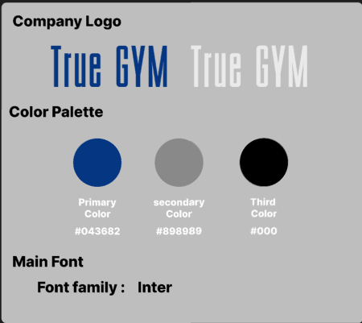**Corporate Identity:**  *(Lecture 3 slide 23)*

**Design Process:**  *(Lecture 3 slide 24)*

* Information architecture

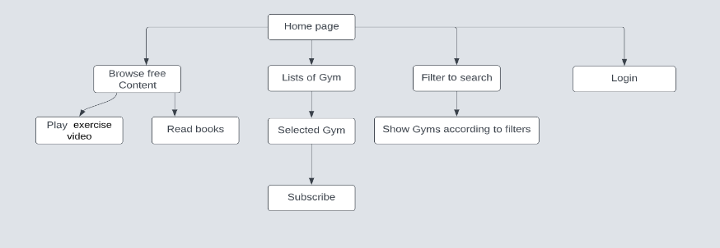

* Sketching: *(Lecture 3 slide 25)*

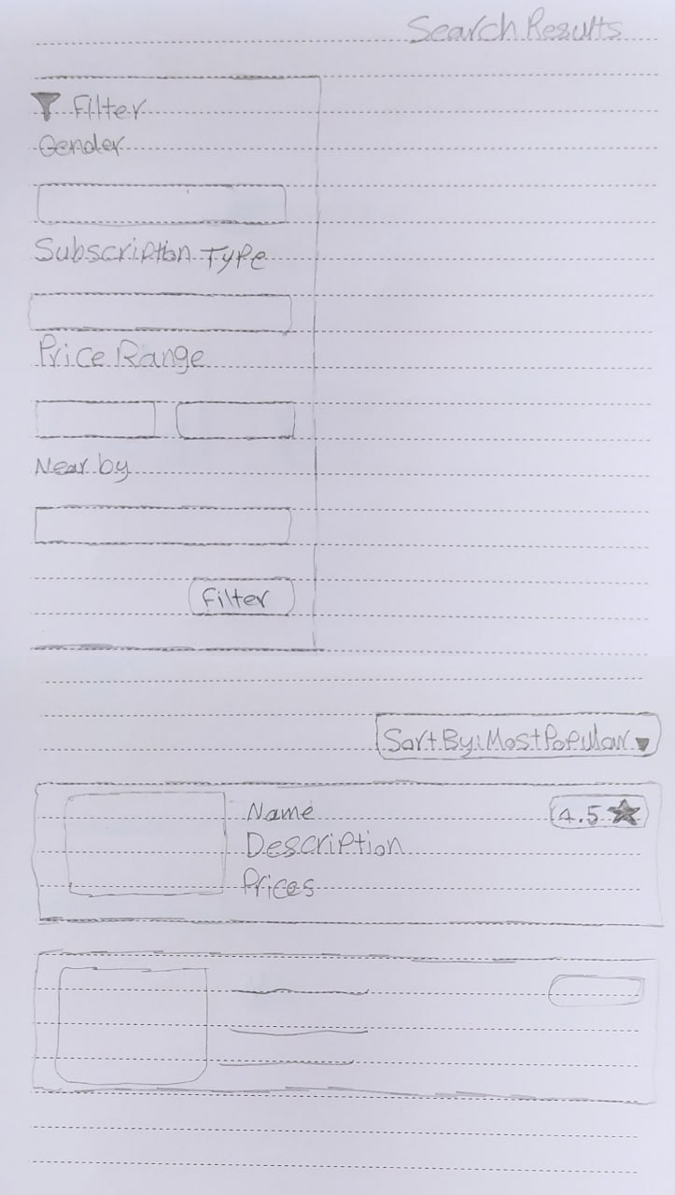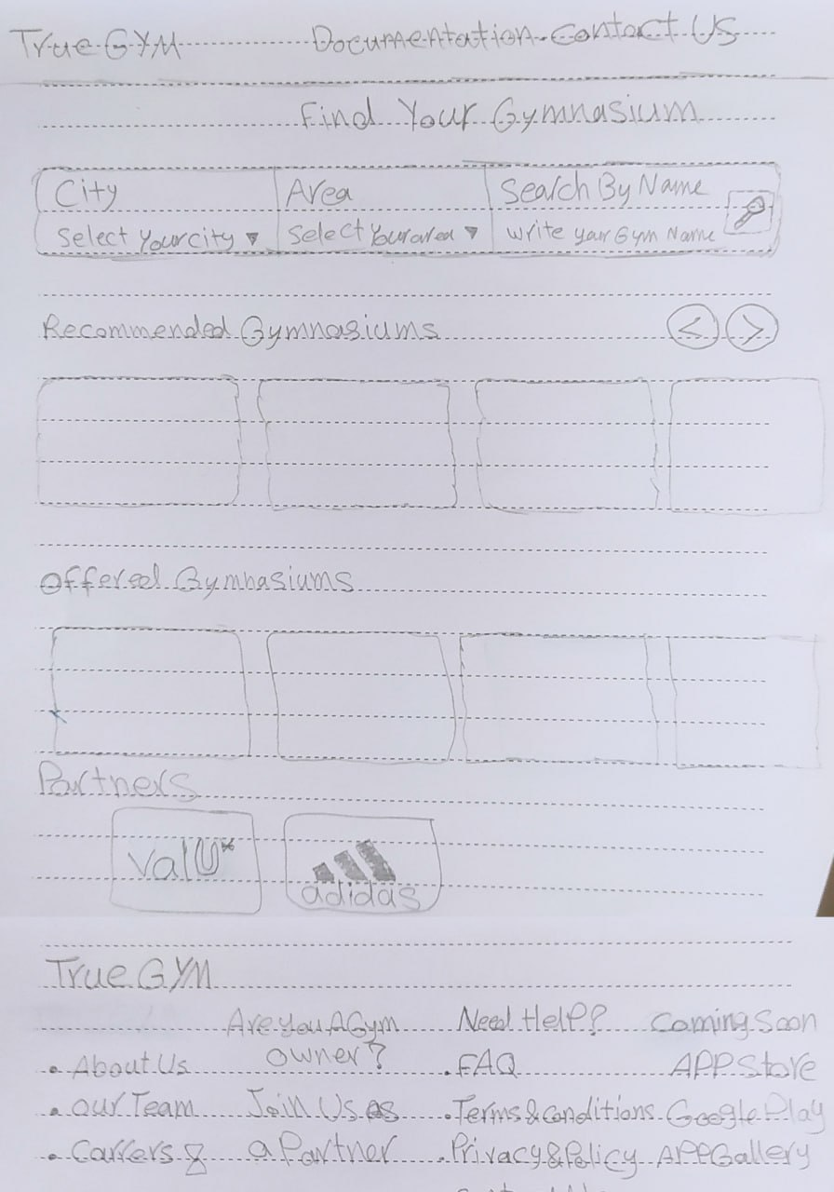1- Home Page 2- Search Results Page

**Quality Assurance** *(Lecture 6 slide 17)*

|  |  |  |
| --- | --- | --- |
| **Test Case** | **Description** | **Expected Result** |
| TC01 Registration to the app | Register new Regular user with some data required like email , full name , location | Full the required data and click on Registration bottom |
| TC02 Login the app | Login via mobile number after provide OTP | Login with valid username and password after provide OTP |
| TC03 Search for available Gyms | Form to show all gyms available for specific location as user determined and can show gyms near the user as location defined with filter at the side of form | Search for available Gyms in specific location and filter with low price |
| TC04 pay for subscription | When user ready to pay the money for subscription to a specific Gym | Select Gym, adding a payment method and click on Pay |
| TC05 Navigate the application Tabs | Navigate the application tabs and confirm that all the tabs are clickable and open successfully | Navigate the home page, Search bar and Gym details |

**Design Pages (forms) for the TrueGYM website**

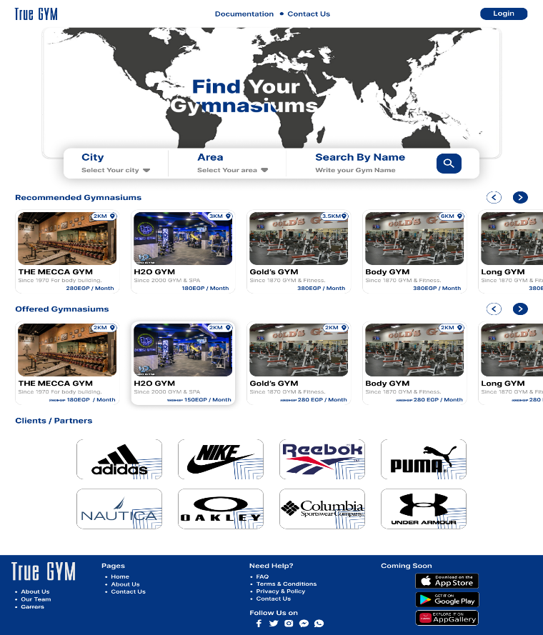1- Home Page 2- Search Result Page

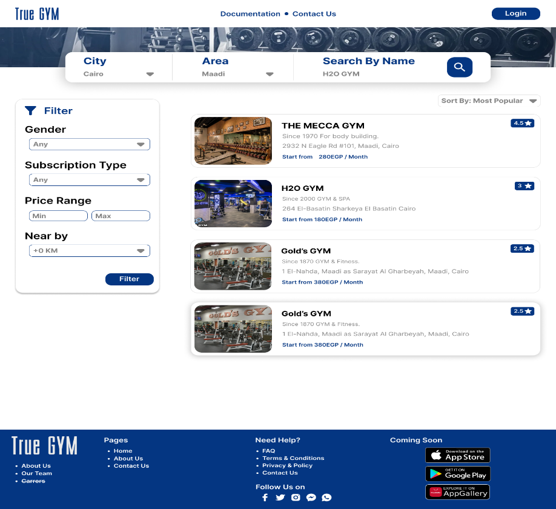

3- Gym Details Page

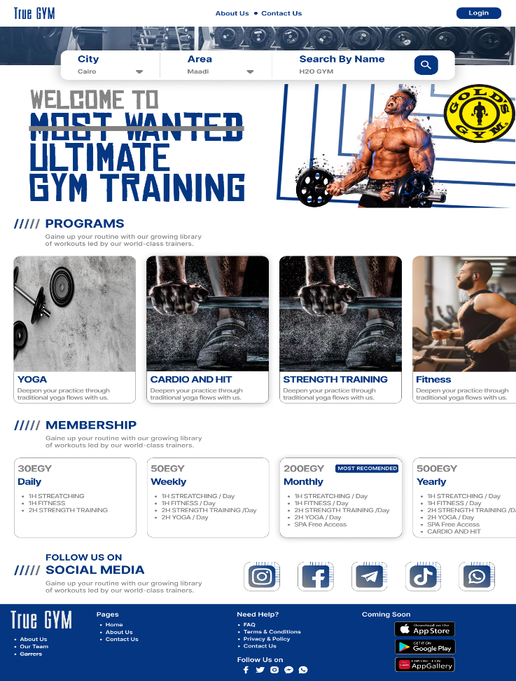

**Links**

Website: <https://truegym.cf> *(Coming Soon)*

Backend: <https://github.com/AhmedFangary92/truegym>

Frontend: <https://github.com/amribrahim34/truegyme-frontend>

UI/UX: <https://www.figma.com/file/clPjyiIh23yckqQv6cijjE/True-Gym---Team-124>